**E-commerce is a parallel world in the retail industry**



*A Report submitted in Partial Fulfilment for the Degree of*

***Bachelors of Commerce/ Bachelors of Business Administration***

VANDANA BHARTI

2012736

WBBBA20900

Department of Commerce and Management

**BANASTHALI VIDYAPITH**

**(RAJASTHAN, INDIA)**

**INDEX**

|  |  |
| --- | --- |
| Chapter | Topic |
| 1 | Abstract |
| 2 | Introduction to topic   |  | | --- | | 1. Retail industry | | 1. E-commerce | | 1. Parallel world | | 1. Change in behaviour of consumers | | 1. Opportunities and predictions | |
| 3 | Literature Review |
| 4 | Research Methodology |
| 5 | Data Analysis and Finding |
| 6 | Conclusion |
| 7 | Bibliography |

ABSTRACT

Digitalization has changed the world entirely earlier when we needed something we need to go out to the market but now we can have almost everything at our home by homedelivery be it food, groceries, clothes, accessories, shoes, a laptop, speaker that to within few days and we can choose out of thousands of choices and the favourable price. We can ever learn anything from anywhere and anytime be it cooking, coding, or doing any online course this all is possible due to digitalization that today we can access all the possible facilities and it is still growing Now, it has almost taken the place of physical markets and malls

The topic of this project report is how e-commerce is a parallel world in the retail industry

We will discuss the past of the retail industry in India and the world and then how it evolved over the centuries and in the last decades. Effect of globalization on the retail industry, how it grows and became the biggest industry

We will be analysing the change in the retail industry in India and study the effects of digitalization on retail and change in the economy and GDP of the country and how it helps in the evolution of India

We will analyse how it got affected by covid how it is going and its future in India

We will also see the changes in the retail industry in the last decade because of the influence of the internet and analyse the present condition of the retail industry and e-commerce and its impact on the retail industry before and after covid 19 (when people got locked at home and had no choice but to online shopping)

We will try to know what people opt for the most shopping in daily life and the thoughts of people in general about their experience covering changes in the behaviour of people and the environment with the interruption of digitalization

Chapter 1

**INTRODUCTION**

1. Retail industry

The retail industry in India is among one of the most important and biggest industries in India. The retail sector makes up to 10% of GDP providing the largest employment of about 35 million in India after agriculture.

After covid interruption around the world, the retail sector players like pantaloons, retail LTD, shopper stop, reliance trends, and future ventures all got shut down for about 3 to 4 months, and even people opted to choose online e-comm services to purchase the products of their daily need which lead to increase in sales online stores like Amazon, Flipkart, Myntra, etc so even many famous brands approach to their website and started promoting online according to their vision and makes success

The industry started with the exchange of goods and services among the people be it in huge amounts or small without the use of money and any monetary substance referred to as the barter system.

It makes the initiation of monetary policy and many came into action. Then the exchange turns into business how they were using money or currency against the products and services earlier this exchange was done through traders and Wenders but as the country evolved to form colonies the evolution needs to needs small stores for products of daily use Kirana stores to come into fashion.

Retail is simply the sale of different goods and services to customers. A retailer purchases goods in high quantities from wholesalers’ producers and sells them to consumers to make a profit

This industry has a very ancient history around the world Retailing practised in the country was similar to the local groceries shops known as Kirana stores and other shopping destinations such as local fares, pavement vendors, etc.

Earlier there wasn't any organized way or pattern for retailing just selling was an occupation for people who wanted to make a profit but were illiterate or merely educated and the only purpose was to meet the daily necessity of consumers and earn their livelihood

They used to have at least one Kirana shop in every colony so consumers have no choice but to buy whatever is available around them. Retailing initially included the basic products of general need but as the time passed, they became a part of the supply chain from Kirana stores they became wholesalers who use to buy products from factories or manufacturers to sell goods to small shops and work as intermediates in supply chains

Later the industry increased to other needs of people like bricks, cement, mortars, computers, and much more, and over the period of time the industry has many competitors in the market for the same products the increasing competition made it difficult for manufacturers to exist in the market this led to the strategic level of marketing for products and services

By the 1980s the retail sector in India was very unorganized so it evolved leading to the production of retail chains big market brands established their showrooms like puma, gold spots, titan, mom and pops stores, Nike, Bombay dyeing, etc

Most modern retailers of this decade are organized retailers consisting of a variety of stores, markets, malls, shopping plazas, showrooms, supermarkets, and branded retail shops it is no longer just about selling but now it’s more about effective supply chain management, merchandising, promotions of products, effective schemes, campaign, pricing and, much more ensuring best possible products at most effective prices to make the daily life easy. The products include everything from farms to kitchens to electric devices …

The retail market in India has emerged as among the most dynamic and fast-developing industries due to constantly increasing new competitors in the country as well as the increasing and developing population of India. Now the retailing industry is emerging more and more through the different online emerging sites and applications for example amazon, Flipkart, Shopclues, Myntra, meesho, jabong, Snapdeal, and much more i.e., e-retailing markets

1. Electronics Commerce

E-Commerce is a method used by modern retailers to complete the need of consumers and give their business a bigger exposure all around the country and for some organizations like amazon it is exposure to the world. It not only satisfies the need of consumers but gives them exposure to billions of retailers and products with a variety of qualities and quantity of choices with colours, trends, and with most affordable and appropriate prices.

E-commerce has become a revolution, especially after covid when people are safer at their homes rather than moving to markets, malls, or bargaining with vendors, e-commerce was the best choice for people sitting at homes willing to explore trends, and foodstuff, dresses, new technology, and a lot.

Benefits of E-Commerce

* E-commerce is done digitally thus it Decreases the cost of creating, processing, distributing, storing, and retaining information
* E retailing is done digitally thus the products are Arranged according to the customer’s demands and requirements
* Helps to reduce the loss to manufacturers as it is demand and can be delivered in the time allotted or decided. Helps to know the interest of customers and trends with leads to the analysis of proper demand of products
* The Internet is much cheaper than value-added networks (VANs). It is also cheaper to send a fax or e-mail via the Internet than direct dialling.
* Products and services are available on phones 24 hours a day and with the convenience of consumers which enables the consumer to shop anytime anywhere
* Customers have a wide range of products and also have the choice of select suppliers and compare the favourable one
* Customers can shop around the world by visiting their official sites or by filtering the products from a particular supplier’s example we can search out only puma shoes from shopping apps
* Consumers cancel the order or return the product if they fulfilled the terms and conditions given and they get the online tracking of product digital sources
* Consumers get weekend sales, festive sales, end of season sales which allow customers to aggregate their orders in some combo or orders together presented by wholesalers or manufacturers
* E-commerce makes the products and services available even in remote areas people in remote areas and developing cities can also access products and services
* Electronic payments make it easy to audit and monitor the payment than payments by other sources cheque, protecting against fraud and theft losses.

1. The parallel world of retail: e-commerce

* Cost-Effective

E-commerce eliminates the link of middlemen between business and customers thus reducing total overhead costs and making cost-effective e-business only need head office means it needs fewer human resources to maintain and generate more profit and also make the product affordable

Whereas the retail business the middlemen plays an important role to sell the products and this business model also need to have branches and human resource to deal with consumers. Thus, increasing the total overhead cost

* Time

Through electronic devices, we can order or sell anything within a few minutes through the internet while in retailing we need to spend a lot of time visiting choosing, and making payments

Hence e-commerce is saving time

* Convenience

E-commerce is convenient to both consumers and producers; the consumer can access information about products anytime and anywhere and can make a payment anytime for the desired product and producers easily get information about an order through the internet

Whereas in retail business we need to move to shops, we cannot access the product 27*7 and select among the products available. So, it’s less convenience

* Accessibility

The products and services offered by the producer through e-comm make it available around the world through websites and shopping apps that can be accessed anytime and anywhere.

Whereas retail business is available as long as the branches of business are available hence it takes a lot of money to expand the business over national to international level and consumers can’t access the products 24*7 like e retail

* introduction of new product

when there is a new product, a new flavour of some foodstuff, new offers, a range of products, or a whole new branch of some company it usually takes a lot of time to make people aware of it to know its performance in the market, the response of targeted customers. With the use of e-retail applications, it has become very easy to launch the product through a website and also to know the response and feedback of customers for the product thus making it easy to judge the new products and predict their demand and progress

* Product suitability

In retail purchases, we can tough, see the size, judge the product efficiently the person get satisfaction for the product. it is suitable for clothes, shoes, edible products, groceries, etc

Through E retail we have to judge the product just by the information available and pictures so it is more suitable for electronic devices, tickets, books, software, packed products like biscuits, soap, body wash, other beauty products, etc and not suitable for perishable goods although in e retail apps such as Amazon, Flipkart, shopclues, Myntra, etc we get the option of returning or exchange of products

* Human resources

Retail business require more human resources than e-retail as it requires staff to deal with the customers to sell the products and maintain the information about sold product or response of consumer whereas in e retail products are available online and also data is managed online very easily

* Fraud

Many people receive calls or messages regarding monetary transactions from fraudulent people informing about new schemes or lotteries and people end up losing their bank balance even some frauds happen during the delivery of online products due to a few loopholes in e retail people suffer monetary losses whereas this is less in retail markets since everything happens in our physical presence and interaction between sellers and buyer

1. Changes in the behaviour of people

Online shopping which allows customers to directly purchase goods and services from retailers using e-stores on the internet and websites with millions of shopping options and paying options with discounts and easy home delivery has changed the entire generation towards the comfort time saving and convenient sources

Through the mode of online shopping, we get thousands of options among products and services to choose the best for us from anywhere and anytime

But have you ever wondered when you make up a mind to purchase something and search for it on different social media sites to get an idea for the product, for example, we want to purchase a dress and we will search it out through some online platform say Amazon you will choose a few products you like and keep it in the liked or basket product and when you close the application you see the same advertisements through different platforms advertising the same?

This is what triggers the mind of the consumer and makes the consumer tend to purchase the dress how the online markets affect the consumer by giving us various discounts over transfer methods, brand discounts, changing the prices, fast delivery options and making the products look more and more attractive

In the end, we end up purchasing one we like the most this is not the end of shopping since we have access to online websites for shopping 24 7 whenever we think of something and try to look for the product or services over the website the same cycle of advertising in triggering the mind continues and make USB more and more products

We must have often seen that nowadays many artists are working as influencers they will wear the dresses and show you how pretty it looks over them and make u buy the same

Increased involvement of internet requests the more and more shopping levels with the hikes of more saving we end up purchasing products more based on us like rather than their uses in life

Name of saving over various discounts or advantages we end up spending more money over irrelevant unnecessary products

While, when it was offline, we tend to visit the markets when we needed and purchase the products we went there for and pay the money by ourselves and know the value of money

1. Opportunities and predictions

Emerging internet and commerce sectors in India are one of the fastest-growing sectors in the country and with the change in consumers behaviour after covid-19 India's digital economy is expected to be US dollars 800 billion markets in 2030 which is 10 times what in 2020

E-Commerce has led to price and digital consumers digital-first businesses emerging and the pronounce digital India introducing UPI, Cowin, Digi lockers, India has digitalised the youth and youth has started more and more online businesses as it is the highest growing sector and has maximum probabilities of getting a success

They have the highest-funded sectors as one of the world's fastest-growing economies they are taking technology to a different level by mixing it with services as fintech involves finance and technology together it involves mobile banking and digital economy the products maybe lead tech digital payments in shortcut net banking investment tech digital landing blockchains emerging use cases market collaboration present examples of intake are payu, phonepe, Bharatpe, Google pay and much more

The youth is also involved in edtech which is studying through smartphones or internet penetrations in education it can involve primary and secondary supplementary education, test preparations, skilling or up-skilling education, languages learnings, coding through unacademy, byju’s, white hat jr., upgrad etc

Agritech start-ups are also becoming a part of modern technology is helps in input market linkages precise farming agriculture financial tax quality management sustainable agriculture and combines it with irritating and providing the foodstuff at door steps through different platforms such as Ninja cart, way cool, agrostar, stellapp, India has reached more than 450 agritech start-ups growing @ 25% year on year

There are endless possibilities with technologies making the country grow and develop giving convenience to consumers and retailers, it is expected to grow by almost $11trillion by 2025

Chapter 2

Literature review

“Digital commerce is going to impact multiple industries & business models. We can clearly see a significant transformation in sectors like consumer healthcare through digitally-driven innovations like HealthKartPlus. Digital commerce will unleash a new wave of innovation in such sectors, where the provision of information, transparency, choice and access would help revolutionize the way this sector has worked. Today, any citizen with a mobile phone can learn about his medicines, compare prices between multiple brands and also become aware of possible side effects and interactions - enabling him to maximize effectiveness and minimize the costs of his medication. The entire space of consumer healthcare, which has been built with inherent opacity for a consumer traditionally, will be transformed into a new model with the consumer & transparency at its centre. This means a huge change in the way healthcare works in India and across the world - and the change has already started with initiatives like HealthKartPlus. Similarly, all such areas where transparency and choice have been missing will get revolutionized by the advent of digital commerce.” Prashant Tandon MD & Co-founder, HealthKart Teas (1994) highlighted that retail store quality is composed of four factors namely upscale, merchandise, transaction effectiveness, and responsiveness. Store aesthetics plays an important role in the formation of perceptions of store brand quality and also enhance the evaluation of the quality of store brands (Richardson et al., 1996).

H. Gupta, N. Dubey and P. Pawan (2012) the broad objective of the study was to understand consumer behaviour towards organized and unorganized retail stores and to find out the consumers’ satisfaction levels from organized retail stores as well as unorganized retail stores. The perception of the traditional retailers about modern retailing. The study uses primary data collected through in-depth qualitative analysis to represent organized and unorganized retail sectors respectively.

Some researchers have examined e-retail store characteristics that are concerned to consumers during different phases of online shopping. Information search is one of the key stages in the consumer purchase process. Before purchasing a product, consumers seek information about alternatives that may satisfy their needs. Quality information helps shoppers learn about products and make informed and better choices. Consumers may seek information about brands, features, functionality, quality, prices etc. Some of the factors that are used to judge information quality include accuracy of information and completeness (Ahn, 2005). Relevant and easy-to-use information plays an important role in influencing online shoppers ((Ranganathan, 2002) (Ho C. F., 1999)). It has been found that information relevance was seen as one of the top website quality factors by both online shoppers as well as managers/designers of e-business companies (Lee, 2006). While information content is critical for a website’s success, navigation is another factor that is related to a website’s success (Palmer, 2002).

Research shows that interactive decision tools that help consumers narrow down alternatives and make detailed comparisons among the shortlisted ones can lead to better purchase decisions with lesser effort (Häubl, 2000). This may lead to more satisfaction with purchases among consumers. Product/brand variety is an important factor that customers seek while shopping either online or offline. Product quality is another aspect that is important to consumers in both online and offline purchases. It has been studied that maximizing product quality for the price paid tends to be one of the fundamental objectives of customers (Keeney, 1999). Shipping charges, which increase the overall cost for consumers can also affect online shopping behaviour. Consumers share personal details like name, e-mail, phone number, address etc. along with credit/ debit card details while making online purchases. Websites also gather information regarding user browsing behaviour using means like cookies. Thus, security and privacy are among the major concerns that consumers have while shopping online.

(Udo, 2001) found that security and privacy are the main factors for the adoption of internet purchases. (Ahn, 2005) found that navigation necessary element of system quality of an internet shopping website. After information search, the next phase in the consumer buying process is comparing and evaluating different alternatives and shortlisting one of them for final purchase. Internet retailing, however, provides an opportunity for retailers to offer decision aids that are interactive and enable consumers to compare alternatives

Several research studies also showed security as one of the most important factors that customers look for while shopping online (Lee Y. &., 2006)

Azzam Al and Mahmoud Abdel Fattah (2014) [17] in their study revealed that perceived ease in usage, perceived, attitude, usefulness and perceived behavioural control are the important essential factors influencing consumer behaviour towards online shopping. The study also revealed that there are no significant relationships between trust and the online

buying behaviour of customers. According to Juniwati (2014) [19] ease in using online shopping mode, perceived usefulness by consumers and risk of payment are the most important factors guiding the attitude of customers towards online shopping. Where attitude of customers and the risk perceived by them are found to have a significant effect on online shopping perception.

Jaya Subramanian et al. (2015) [14] in the study regarding the level of satisfaction of customers while doing online shopping reveal that apart from various advantages offered by online shopping the customers’ risk of fraud and threat of privacy of information due to hackers are a major concern for the shoppers during online shopping.

A study conducted by Rahman et al. (2018) [16], reveals that time-saving and wide variety of products offered is the most important features considered by customers regarding online shopping. Male and females both show similar types of behaviour towards preferring or disliking factors. The option of home delivery in online shopping is most preferred by customers while the inability to touch the product is considered the most prominent disliking factor by the customers. Social networking sites are found to be the most acceptable source of information regarding online shopping whereas consumers are most concerned regarding the security of payment.

Chapter 3

Methodology

The research paper is based on the topic E-Commerce a parallel world in the retail industry

The retail industry has grown a lot since the last decade of the internet and is growing constantly but will it be able to take place of the whole retail industry and will be still working perfectly and common like earlier to get to come conclusion

In this paper, we will discuss various changes in the marketplace in two different qualitative and quantitative data through the methods and addressing the issues and try to understand the parallel world of the retail industry and its impact on India

We will address the following issues in the research paper

* We will see the changes in the retail industry in the last decade because of the influence of the internet

The method used will the analytics from the various platforms and rank around the world and changing data over the years

* We analyzed the present condition of the retail industry and e-commerce

The method used is the analysis of various years

* Try to analyze the impact of the retail industry before and after covid 19 (when people got locked at home and had no choice but to online shopping)

The method used is to mix the stats available

* What people opt for the most shopping in daily life

The method used was the opinion of people through the most visited websites in India

* Changing behaviour of people and environment with the interruption of digitalization

The method used was the opinion of people and psychological study over people changing behaviour towards shopping

Although e retails have almost similar to the retail industry but through this study, we will also notice the changing behaviour of the market targeted and if people are really satisfied with the websites and applications Flipkart, Amazon etc.

The methods used to study the issues above were both quantitative and qualitative which means the methods involved public opinion through interviews, google analytics and statistical data from the internet about the last decade to know people’s opinions about malls and e-comm websites

Limitations

Although we tried to cover all possible issues and important parts of the study the study still has left questions to be answered

* Will malls and supermarket lose their importance and will be shut down over a long race in e-retail?
* Are people satisfied or this is just due to the demand of the situation?
* Impact of e-retailers on small retailers?
* Almost everything is available online now but are people really satisfied with all kinds of products available online?

Chapter 4

Data Analysis

The emergence of internet facilities and technical penetration has entirely altered the way we communicate, learn, deal or even do business as previously discussed earlier we were very slow and technically backwards but now we are technically driven and heavily dependent on the internet. today we need technical gadgets such as phones, laptops, and tablets for almost everything from checking stocks, getting something new, talking to people, working, learning, or be it life necessities like ordering food, groceries, clothes and the list goes on

The retail industry has changed a lot in since last decade because of growing internet facilities the stats say India just has 15000 e-mail accounts till 1992 but now India ranks second in the world in terms of active internet users is nearly 50 per cent of Indian

The emerging internet facilities are growing regularly in India making us more and more addicted to it and online businesses are making billions of profits by proving unlimited choices of products and facilities at affordable prices and delivered to doorsteps

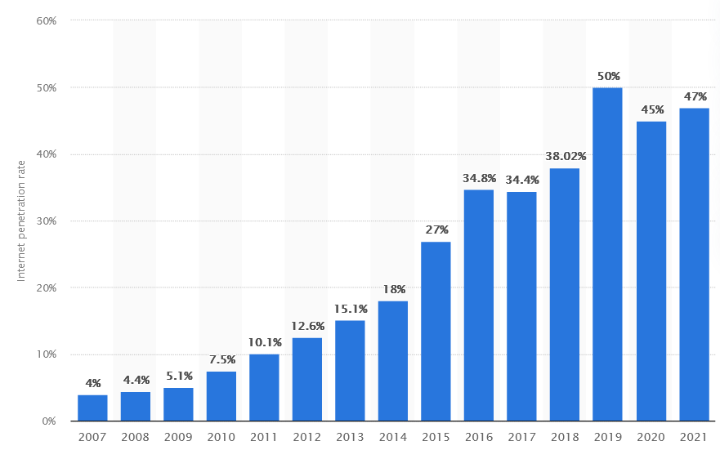

With the growth of the internet, the digital market grows, and the e-commerce market generates revenues in India the market grew 38.5 per cent around 2020 expected to slow-growing revenue by 2025 if everything remains suitable and situations like covid never repeat

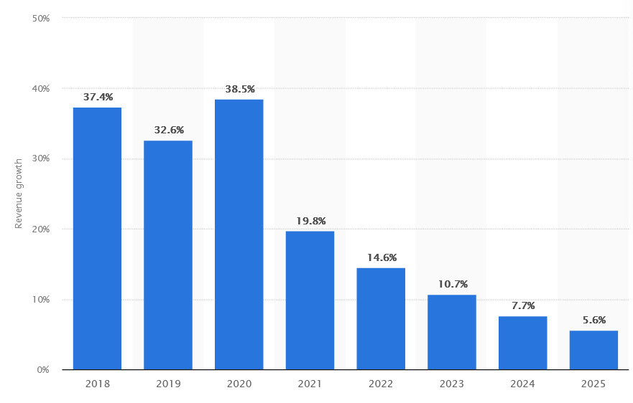

Now India is the world’s fifth-largest global destination in the retail space, 73 in trade and development business to consumer (2017)

India had the 3rd online shopper base of about 140million in 2020 after China and us now, India ranks 2nd in retail e-commerce sales growth, and e-commerce is significantly contributing to the growth of India there are 19000 e-commerce companies and India and it is still increasing day by day and is expected to grow more in coming years with time and requirement of population and technology demands

We can see the significant growth in the revenue and sales in e retailers around 2020 when coronavirus disease came up and we were forced to stay at home in isolation for prevention of covid 19 for a noble cause so that we are safe and condition of the country remain stable even the government facilities were stopped. In 2020 many nations were at their worst and were about to collapse. the death ratio around the world was high only because of coronavirus but what made the revenue and GDP still grow let’s try to understand

When people got locked up at home, they spend time with family and the internet got to know about a lot of new things, series, courses, created YouTube channels and find it better to spend time. They purchased Hotstar subscriptions, Netflix, amazon prime, and online reading apps but all the requirements lead to a shortage of devices and when people explore a lot of things they wish to purchase things when all the lockdown is over they waited for it over after about 3 months of lockdown the demands of products increased very quickly, especially for electronic gadgets, clothing, accessories, footwear, kitchen equipment’s, home decors and much more now the sales got enhanced and were more than what was even before maybe people were purchasing in the fear that lockdown may happen again and they need to stay at home, work from home, and they need all that for all comfort and completing their necessities but after few months people understood that for their protection they need to be safe and spent the most time at home or keep themselves away from people.

Now with covid, digitalization became a blessing in disguise. many small retailers who were not able to sell things and suffered losses and were not even able to pay rents understood that if they want to survive in the market, they need to get worldwide exposure on the internet. They then wanted to go online but they don’t know about routes many big companies like Amazon, Flipkart, Myntra, and shopclues meesho helped small retailers by making them participate with some commission. The main advantage was people can access the internet 24*7 anytime and anywhere and purchase according to their choices no negotiation, no bargain, less human resources needed just need to match the demands of customers. Although there were many disadvantages’ consumers had no choice but to be happy with them there were a lot of financial frauds but the population at home had no other choice. Small retailers not only increased the choices for people but help the online services to reach even remote areas and villages

When sales start to grow, according to the Confederation of All India Traders (CAIT) alone India spent Rs 1.25 trillion during Diwali shopping, surpassing a 10-year record. Alone festive season generated about Rs 25,000 crore in revenue in Delhi.

E retail became a boon during covid, in India, the online market is projected to reach US$ 350 billion by 2030 from an estimated US$ 55 billion in 2021, because of rising online shopping and increasing online players in retail, and new participants in technology in the country. The new India is doing an online thing, in 2020, the most common payment methods online were digital wallets (40%), followed by credit cards (15%) and debit cards (15%). Now we study online, work online, and learn online. Online penetration of retail is expected to reach 10.7% by 2024 versus 4.7% in 2019.

Now let us what people opt most for shopping and why

People after covid tend to spend more time at home as they need to have preventative masks and sanitisers still to keep themselves safe from covid the conditions are getting better day by day with vaccination but we are still not normal and afraid of a burst of covid-19 in India as it has happened twice till 2022 and people have no option but to live like this until the covid is over and no new variants are coming

Most people choose amazon and Flipkart for shopping

So many visitors to amazon and Flipkart and sales a variety of products but are people really satisfied with the products they buy online or its just because they don’t have any choice

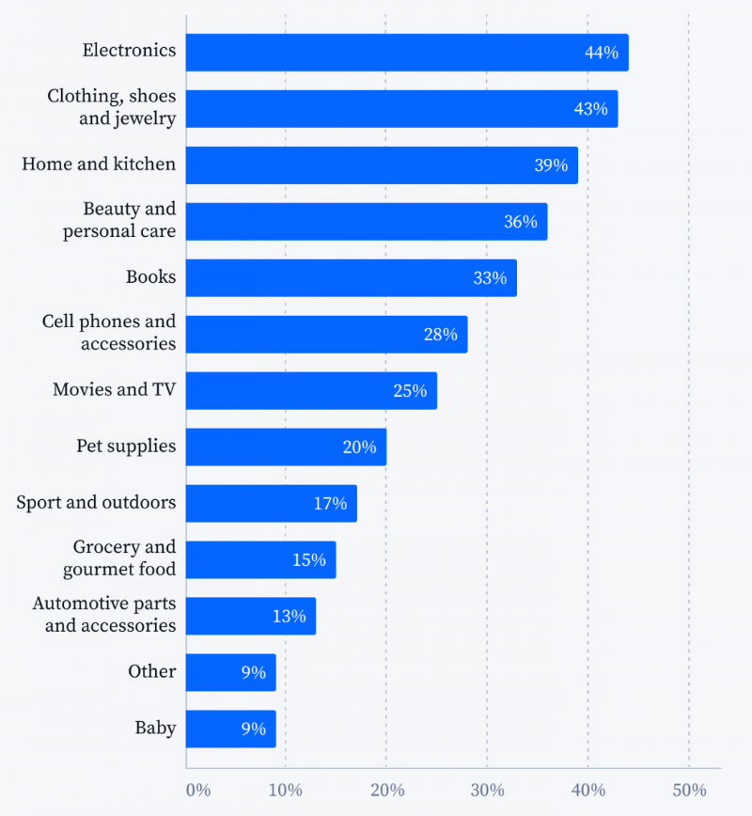

As we can see from the data given people tend to buy more electronic gadgets, than clothing and accessories as they are a necessity of life and is a definite quality product if its branded or got good reviews and ratings and people buy very grocery, gourmet food or baby products even less than 10 per cent

When I asked about online shopping about 25 people about 18 of them were not satisfied for the following reasons

* Not able to touch, feel, and try the product
* Lack of physical shopping experience
* Scam & fraud issue
* Lack of interactivity
* Possibility of damage to fragile item
* Delay in delivery

After so many disadvantages the market is growing each passing day and making the new models in strategies work very well this all is not just because it is the need of the population but now the retail industry is 24/7 enhance of the population through electronic devices and as we all know the population is heavily depended on electronic devices

The Transformation of the retail industry into e-commerce is changing into an interesting face the small retailers are disappearing and digital businesses are transforming into big E-Commerce businesses to make their products influence people

We can have some idea of how much the population is getting influenced by digital retail by the following points according to surveys

* customers search for the product first on google and then on some other website to purchase
* people see a product about 25 times before shopping
* consumers look for the product from about 16 to 17 days before making the purchase
* consumers spend about 5 hours on average on shopping apps
* About 67% of consumers have increased their shopping after the pandemic
* Nowadays advertising influencing merchandising is also playing a great role by the sources of social media
* About 56% of consumers get influenced only by posts from social media

Conclusion

Retail industries changed drastically period of time earlier we just have merchants, vendors, shopkeepers, and shops but the era of digitalisation has changed the entire industry and the consumer now you have online platforms applications like Shopify Amazon Flipkart Myntra ShopClues meeshow and much more

eCommerce industry was growing slowly before covid but the covid 19 in 2019 and 2020 has changed the entire industry the population around the world got dependent on digital and electronic devices when the people suffered lockdown the need for these devices increased too much the demand in the market the industry sold the device is more than usual the industry grow up to 40 per cent in 2020, grossing $38 billion GMV (gross merchandise value), up from $27 billion in 2019.” Indian e-commerce grossed $22 billion GMV in 2018.

The internet penetration not only influenced the market but also has changed the behaviour of people due to the advantages of e retail industry it is available anywhere and anytime which made the consumers access to the market through online websites and applications from anywhere even in remote areas

Application and internet are available 24/7 means consumers can access the information about products anytime this advantage has influenced the consumers so much that on an average consumer when 5 hours on application searching for the product

E retail market gives millions of choices and options to buy almost everything from footwear to clothes to kitchen accessories and jewellery. consumer get so many choices sitting at home that they don't even bother to visit the market and shop they sit at their places and easily shop from retailers online available it not only gives the choices with products but with prices and discounts on paying options and nowadays super coins

This was earlier just for the big brands but now it is available for small retailers this has benefited both the consumer and the retailers or producers that India spent Rs 1.25 trillion during Diwali shopping, surpassing a 10-year record. Alone festive season generated about Rs 25,000 crore in revenue in Delhi. If eCommerce market-size projections are to be believed, digital shopping will only continue to grow more important. Technical innovations like drone-based delivery systems and autonomous vehicles will accelerate the trend.

Bibliography

* <https://www.researchgate.net/publication/289504372_The_effects_of_E-commerce_on_the_demand_for_commercial_real_estate>
* <https://manipaldigital.info/blog/retail-industry-how-it-is-transforming-into-ecommerce/>
* [(PDF) The Retail Industry: Expanding in the Global Market (researchgate.net)](https://www.researchgate.net/publication/321151046_The_Retail_Industry_Expanding_in_the_Global_Market)
* [(PDF) Evolution of Retail Industry in India | SUBIDITA PATTANAIK - Academia.edu](https://www.academia.edu/39763275/Evolution_of_Retail_Industry_in_India)
* [Indian Retail Industry, Retail Industry in India, Retail Industry, Retail Industries (indianmirror.com)](https://www.indianmirror.com/indian-industries/retail.html#:~:text=History%20%20The%20origins%20for%20retail%20business%20in,the%20help%20of%20Khadi%20%26%20Village%20Industries%20Commission.)
* <https://www.ibef.org/industry/retail-india>
* https://www.tidio.com/blog/online-shopping-statistics/#is-there-an-increase-in-online-shopping
* https://www.researchgate.net/publication/293517608_Consumer_Behavior_in_Online_Shopping_A_Study_of_Aizawl
* <https://fortunly.com/statistics/ecommerce-statistics/#gref>
* https://blog.hubspot.com/marketing/buyer-behavior-statistics